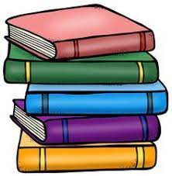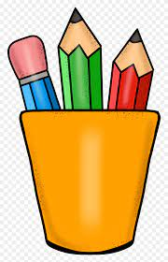

***Middle School Supply List***

Backpack

Pens – Blue and Black

Pencils

Pencil sharpener

Dry erase markers

Water bottle

Box of colored pencils

Highlighters

Headphones/Ear pods

6 – 10 Folders

4 – 6 - single subject notebooks

2 – 3 - composition notebook

3 ring binder or zipper binder

Pack of loose-leaf paper

Index cards

***Classroom Supplies***

Box of tissues

Papertowels

Wipes